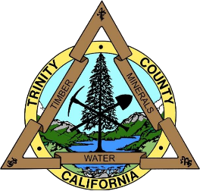
Trinity County Veteran Service Office

Disability Compensation Fact Sheet

Disability compensation is a benefit paid to Veterans who suffered injuries or were diagnosed with an illness while on Active Duty.

Eligibility
You may be eligible if:
- You have a service-related injury or illness
- Your service aggravated a pre-existing injury or illness
- You were injured while under the care of the VA
- You were discharged under conditions other than dishonorable

Compensation Rates
Varies by percentage of disability granted and type/number of dependents. See the US Department of Veterans Affairs website for more information.
https://www.va.gov/disability/compensation-rates/veteran-rates/

How to apply
Contact your Veteran Services Office for help with a compensation claim. The claims process is long and difficult to navigate. The Trinity County Veteran Services Office is dedicated to helping Veterans submit complete, fully developed claims while attempting to obtain a service-connected disability rating. Bring the following documents to your appointment:
- Discharge or separation papers (DD214, DD215, etc.)
- Dependency records (marriage license, divorce decree, children’s birth certificates)
- Medical evidence (medical records, doctor/hospital reports)
If you do not have all of these documents, the Veteran Services Office may be able to help you attain them.

Related Benefits
Those granted a service-connected disability rating may be eligible for additional federal and state benefits. Contact your Veteran Service Office for more information.
- Medical Care
- Vocational Rehabilitation
- Clothing Allowance
- Housing Adaptation Grants
- Automobile Grant and Adaptive Equipment
- Service-Disabled Veterans Insurance
- Federal Employment Preference
- Military Exchange Privileges

